In this Replication stage, I did the User Acceptance testing to replicate and show the buggy behavior ﻿﻿﻿﻿﻿﻿﻿﻿﻿﻿﻿﻿﻿﻿﻿. There were 2 reported bugs i.e. First one was that service charges are shown as 0.0 during checkout and other one was that it was possible to charge a room for service even after checkout. First, I started by booking the room and room booking screenshot is given below.

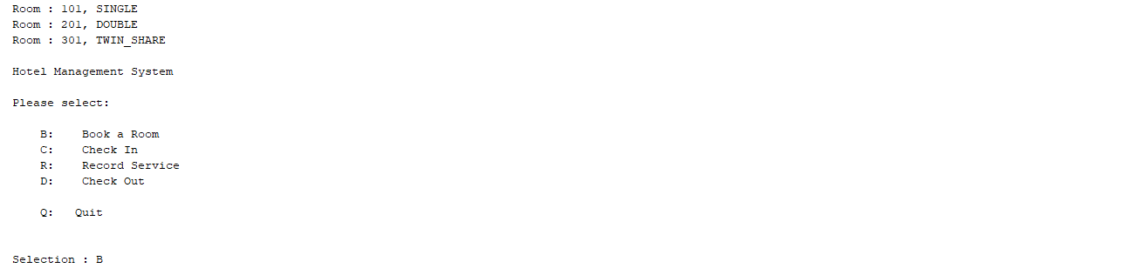

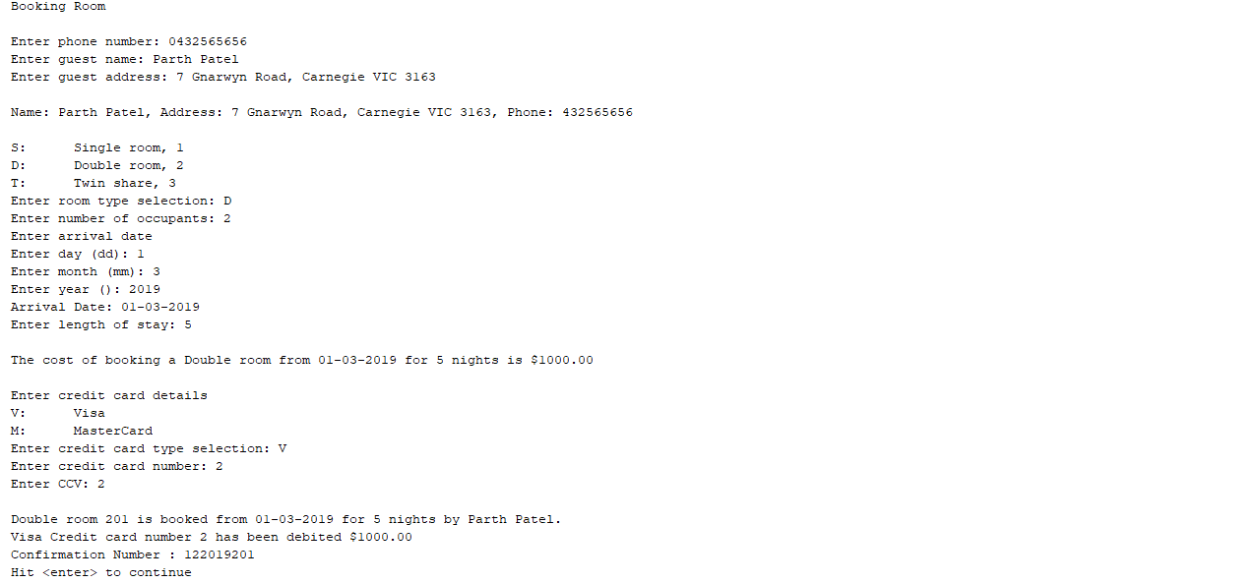

Then, I checked into the room and so the checkin process was also successful and there were no reported bugs and the screenshots can be found below.

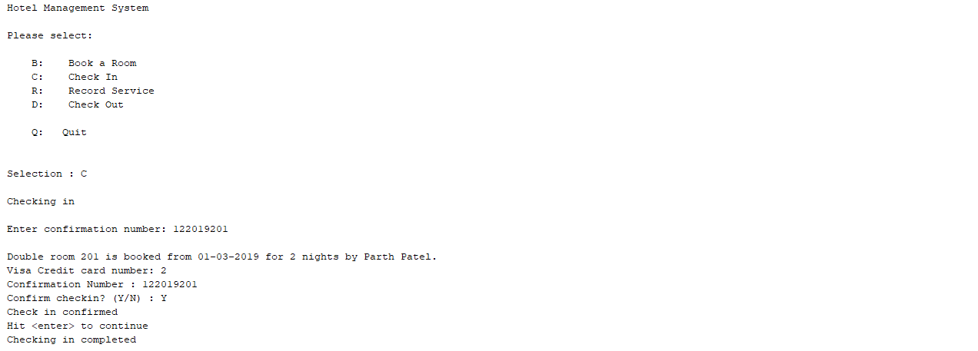

After that, Record Service process was done and it also passed and there were no reported bugs. I can successfully add the service charges and when this process was finished it is showing correct total of service charges. The screenshots are given below.

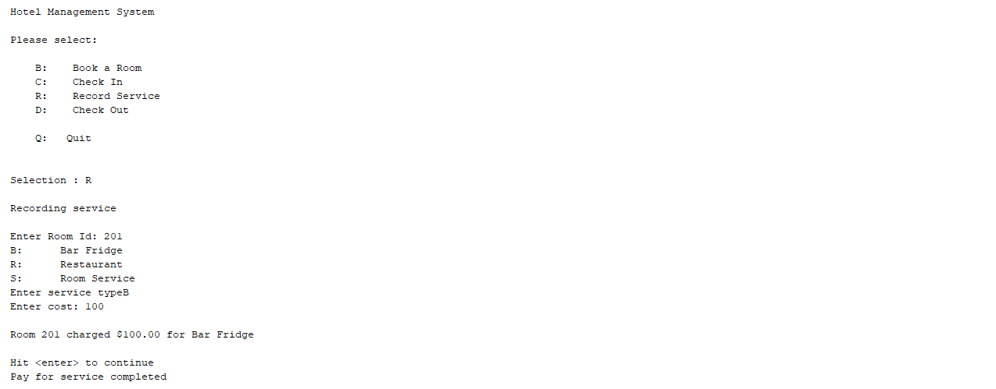

Then, the checkout process was done. It is shown in the screenshot that the service charges are reported as 0.0 and this is the first bug. The screenshot is shown below.

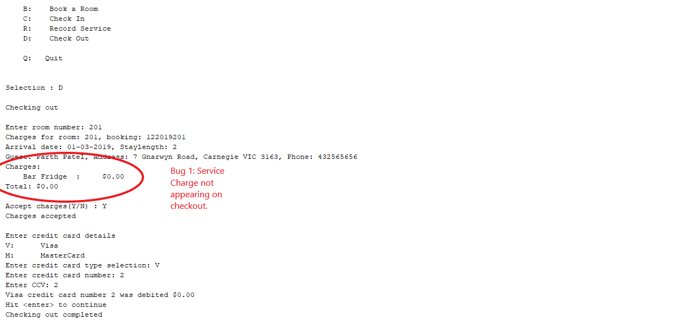

The second bug is that the room can be charged service charges even after the guest has checked out. It can be seen in below screenshot that the guest of room 201 was again charged service charges even after the guest has checked out as shown in the previous screenshot. This is the second bug and it is shown clearly in the below screenshot.

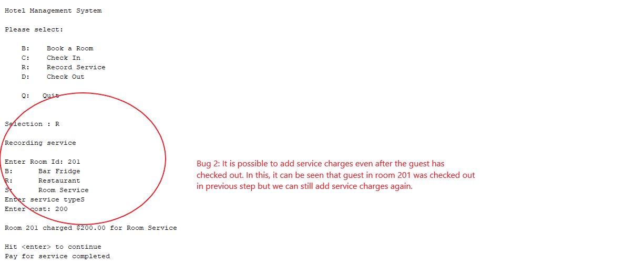

After adding more service charges it shows correct total, but during checkout it will still show 0.0 as shown in screenshot. The below screenshot is of guest of room 201 which was checked out before, then more service charges were added even after the checkout and then checkout is done again.

